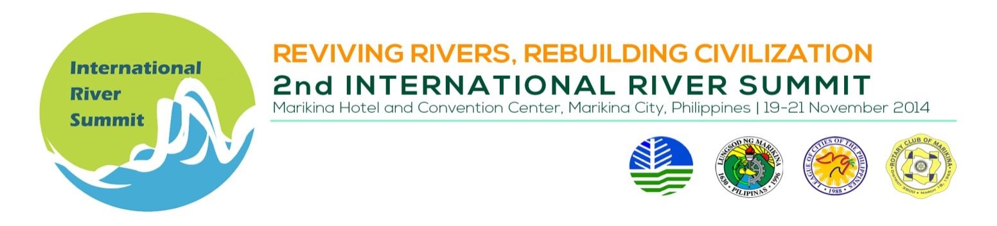
INDICATIVE PROGAMME

Thematic Session 5 : Resilience Building in River Basin Management

Venue : El Valle, 3rd flr, Marikina Hotel

Date/Time : November 19, 2014, 1:30 – 5:00 PM

Session Chair : Mr. Vic Aquitania, Executive Director, ICLEI-Southeast Asia

TIME | TOPIC | SPEAKER
 | SESSION INTRODUCTION | Mr. Vic Aquitania
 | Climate change adaptation and disaster risk reduction (CCA-DRR): An overview | Dr. Kristoffer B. Berse, National College of Public Administration and Governance, University of the Philippines
 | Promoting CCA-DRR in Southeast Asia | Dr. Marqueza T. Reyes, Technical Advisor for DRR, ASEAN Secretariat
 | BREAK
 | CCA-DRR River Management: Philippines (Climate Twin Phoenix Project) | Ms. Maria Lovella Segayo, Development Management Officer,  Climate Change Commission
 | CCA-DRR in River Management: Indonesia | Dr. Yuli Suharnoto, Center for Climate Risk and Opportunity Management in Southeast Asia, Bogor Agricultural University
 | CCA-DRR in River Management: Malaysia | Engr. Mohamad Hafiz Bin Hasan, Senior Assistant Director, Department of Irrigation and Drainage, Malaysia

